Web Solutions Platform Event System:
A Distributed Publish/Subscribe Event System

High Performance and Low Latency

April 2006



Keith Hamilton, Software Architect
Table of Contents
Abstract 2
Types of Publish/Subscribe 2
Message-Oriented Middleware Based Systems 2
WS-Notification 3
Others 3
Special Purpose Systems 3
Jabber 3
Characteristics of the Problem Domain 3
System Virtualization 4
Application Virtualization 4
Metric Collection 4
Description of the WSP Event System 4
Subscriptions 4
Topology 5
Event Routing 5
System Structure 6
Design Considerations 7
Serialization 7
Communications 7
Inter-Process Communication 7
Managed vs. Unmanaged 7
Performance 7
Parent Machine Configuration 7
Child 1 Machine Configuration 7
Child 2 Machine Configuration 8
Child-to-Parent Round Trip Test Case 8
Results 8
Child-to-Child Round Trip Test Case 8
Results 8
Uni-Direction Test Case 8
Results 9
Proposed Improvements 9
Re-Write in Unmanaged Code 9
Move from Hierarchy to True Mesh using Reliable Multicast 9
Coding Examples 10
Defining an Event Type 10
Publishing Events 11
Subscribing to Events 11
Conclusion 11

Abstract
The Web Solutions Platform (WSP) event system is a general-purpose distributed publish/subscribe event system designed for high performance and low latency. Publish/subscribe is a common communication pattern though there are many variations to solve different scenario requirements. The Windows platform lacks publish/subscribe functionality that would meet many scenario requirements. The WSP event system provides a publish/subscribe solution for many scenarios, especially for scenarios where performance and latency are important.

Types of Publish/Subscribe
Publish/subscribe is not a new paradigm. There are several different types of publish/subscribe which support various scenarios. Some differing characteristics of publish/subscribe systems are:
- Coupling
Are the publishers and subscribers loosely-coupled?
Do the publishers and subscribers know of each other?
- Brokered subscriptions
Is there a broker who knows about all the publishers and subscribers?
- Persistent subscriptions
Are subscriptions persistent or transient?
- Delivery of events
How are events delivered? Guaranteed? Best effort?
- Routing
Are events routed via content? Or via event type?
Is routing centralized or decentralized?
Because of differing scenarios, there needs to be different types of publish/subscribe systems. We see this similar need for two resources to communicate with each other in networking. For instance, two resources could communicate via UDP, TCP, MSMQ, COM, RPC, shared memory, or named pipes. It’s not that one means of communication is better than another; it’s that there are different scenarios requiring different solutions.

Message-Oriented Middleware Based Systems
One approach for implementing a publish/subscribe pattern is to build it on top of a message-oriented middleware infrastructure. This approach will normally support persistent subscriptions and guaranteed delivery of the events. It tends to be a heavy weight solution with low performance but provides rich delivery of the events. This solves some scenarios very well.

WS-Notification
“WS-Notification is a family of related white papers and specifications that define a standard Web services approach to notification using a topic-based publish/subscribe pattern.” This type of publish/subscribe system is designed to compose with the other WS-* standards and can provide rich eventing. This type of publish/subscribe would require substantial overhead and be analogous to two resources communicating via MSMQ. This may be good for some scenarios but not for where you want high performance and low latency.

Others
There are many examples of publish/subscribe messaging patterns implemented on a message-oriented middleware infrastructure. IBM’s MQSeries, JMS, and Oracle’s Enterprise Service Bus all support publish/subscribe. These too would provide rich eventing features but not when you want high performance and low latency.

Special Purpose Systems
There are many publish/subscribe products available on the market. These products vary widely on their features and therefore on their performance characteristics. There are some that are for handling real-time data and have high performance and low latency. Others are more general purpose and tend to be focused on sending XML events. In this instance, performance tends to drop.
Jabber is an example of a special purpose publish/subscribe implementation.

Jabber
“As Jabber technologies have matured, the need for a generic publish-subscribe mechanism has arisen in a number of problem spaces. These include (but are not limited to): news feeds and content syndication, avatar management, shared bookmarks, auction and trading systems, online catalogs, workflow systems, network management systems, NNTP gateways, vCard/profile management, and web logs.”
Jabber has the notion of a publish/subscribe service that acts as a broker for subscriptions and for delivery of the events. There are notions of nodes and topics. The events are XML. The Jabber publish/subscribe is similar to a hybrid of WS-Notification and Representative State Transfer (REST). The performance characteristics would be better than WS-Notification but not high performance and low latency.

Characteristics of the Problem Domain
There is a need for applications to communicate asynchronously more and more. As the operating environment becomes more virtualized, the applications too are becoming more virtualized. This puts more demands on the communications infrastructure. The existing WS-* standards solve some application scenarios fine but do not solve scenarios where high performance and low latency are essential.
For enterprise web applications, there are three primary types of scenarios where high performance and low latency eventing is needed: system virtualization, application virtualization, and metric collection.

System Virtualization
A web farm is an example of a virtualized system. One of the problems though that exists with Microsoft’s IIS is that it doesn’t virtualize the system services across the web farm. So for instance, the ASP.Net cache is scoped to an AppDomain. This means a cache can’t span applications let alone machines. For many applications this means the cache can not be used. Since the cache can’t span machines also means the cache can not be used unless affinity is used when you are using a web farm. For performance reasons, it is not desired to use affinity.
A distributed cache is one example where a distributed publish/subscribe event system could provide a solution to improve system virtualization. Having high performance and low latency means it would be practical to have a common shared cache across application boundaries and a distributed cache across machine boundaries. Each cache would receive updates from other caches within milliseconds allowing caches to remain synchronized.

Application Virtualization
Applications are also moving to a loosely coupled paradigm. This can provide better scalability and can simplify innovation by reducing the complexity of tight coupling and dependencies. As applications become more virtualized, the need for communications becomes more important. As in the networking world, there isn’t one type of communication that solves all the scenarios. In some instances, a directed messaging like WS-RM may be just right. Or a publish/subscribe built on top of WS-RM might be appropriate if you need durability and don’t require high performance and low latency.
For enterprise web applications, there are needs to have an application virtualized across the web farm and still have it behave as one logical application. The general pattern is where the front-end components reside on the web servers and send events to a back-end component which correlates and processes events. One example is where you want to have a dynamic web site and this dynamic behavior is driven by a back-end recommendation system. In this case the front-end web components send events to the back-end recommendation engine which provides the recommendations back to the front-end. For this example, high performance and low latency is essential.

Metric Collection
A common scenario for web applications is metric collection. It is essential to track all the user activity at a web site. The activity metrics feed into the BI system and are used for web site personalization, campaign management, and web site improvements.
At Microsoft.com, there are about 2000 events per second that must be collected. To efficiently collect this many events at this rate, a high performance and low latency event system is essential.

Description of the WSP Event System
The WSP event system is a distributed publish/subscribe event system. It is distributed in that the publishing and subscribing of events can be intra-machine and inter-machine. Publishers and subscribers do not know of each other’s existence although a publisher could listen to subscription events to determine if there is an interested subscriber to its events prior to publishing.

Subscriptions
Events have an EventType property to define their type. This property is a GUID which allows for anyone to define their own event type without worry of conflicting with event types created by other individuals. Applications subscribe to event types. The application can subscribe to specific event types or to all event types.
Each subscription made is assigned a subscription ID. A subscription event is then published throughout the mesh for this subscription ID and event type.

Topology
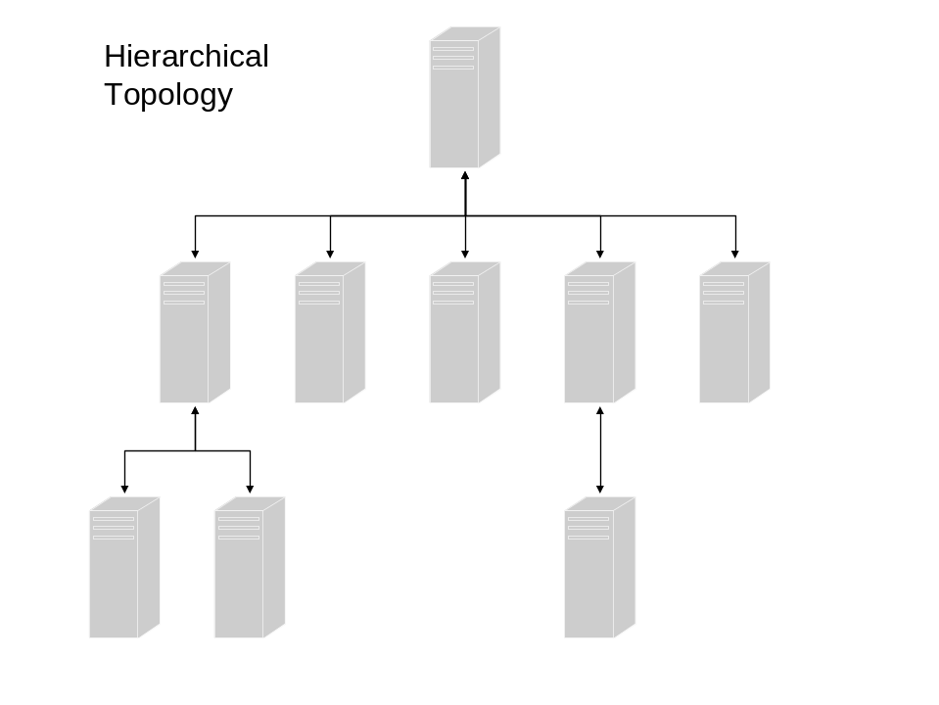
The machines in the eventing mesh are organized in a hierarchy. Each machine knows who its parent is and the parent learns about its children as they connect. Communication between machines is done using TCP.
If events are sent between siblings, the events are sent from the publishing machine to the parent machine and then down to the subscribing machine. Regardless of how many subscribers there may be from the parent onward, the event will only be sent once from the child machine to the parent machine (or parent to child if that is the case). The parent will in turn route the event on to its parent and/or children as appropriate.
From the performance results, the hierarchy topology performs well though this could be improved. The performance test shows it takes 3.5 ms to round trip an event from a child machine to the parent machine and then an acknowledgement event back.

Event Routing
Routing tables are built and maintained dynamically similar to how network routers maintain routing tables for IP multicast. Subscriptions are handled by sending subscription events throughout the mesh. Each node uses the subscription events to maintain its routing tables. When events are published on a machine or routed to a machine, the event system will forward the events across the physical network connections where subscriptions exist.

System Structure
The WSP event system is composed of a collection of loosely-coupled components. The system runs as a windows service with each component running in its own thread. The components communicate with each other through in-memory queues.
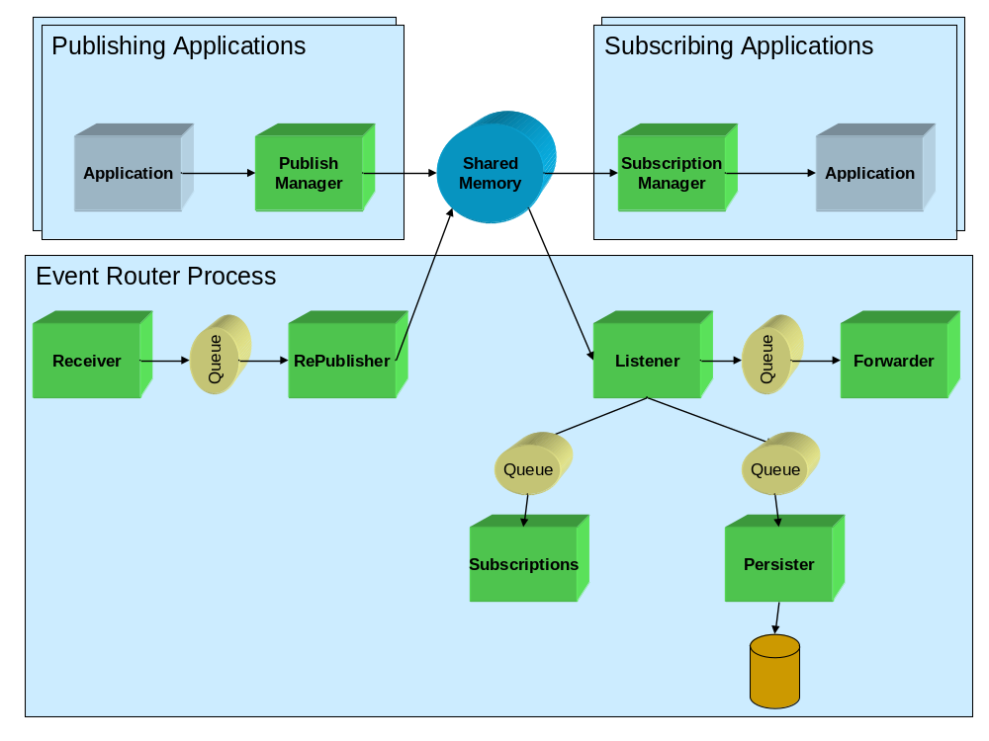
The diagram above shows the main components of the system. The Receiver and Forwarder are the communications interfaces to interact with the parent and children machines. When an event arrives to the Receiver, it hands the event off to the RePublisher to publish the event on the local system. Publishing the event means putting it in the Shared Memory buffer. Interested subscribers copy the event from Shared Memory as does the Listener. The Listener forwards the event to the other components, if appropriate. If the event is a subscription event, the Listener sends it to Subscriptions to update the routing tables. If the event type is to be persisted, the Listener forwards the event to Persister. If the routing tables indicate the event needs to be forwarded, the Listener will forward the event to the Forwarder to route the event.
For publishing applications, they simply put the event into the Shared Memory buffer. When the publisher and subscriber are on the same machine, the event is placed into Shared Memory by the publisher and taken out of Shared Memory by the subscriber. It never incurs the overhead of going through a broker, e.g. the event system. Since there can be N subscribers listening to what events are placed into Shared Memory, this allows for all N subscribers to get the event at the same time and very efficiently.

Design Considerations

Serialization
In early performance tests of standard .Net binary serialization, it was obvious .Net serialization was far too slow to achieve the performance targets necessary for the event system. Instead, custom serialization was used which performed much better. Custom serialization resulted in much smaller payloads and in about an 8 times improvement in performance. This is significant.

Communications
TCP sockets were used for inter-machine communication. This provided the least amount of protocol overhead. Any other protocol, e.g. WS-*, would simply add overhead, reduce performance, and not provide any benefit. The new classes in .Net Framework 2.0 also make using sockets fairly trivial.

Inter-Process Communication
.Net does not provide a performant means for IPC. This is definitely a lacking in .Net. To get good IPC performance, shared memory was used. Since .Net does not provide support for shared memory, unmanaged code was used to implement shared memory and this was wrapped with a managed class. This was the only unmanaged code in the system.

Managed vs. Unmanaged
Many people have the impression that managed code cannot perform. Having written the event system in managed code, with the exception of the shared memory implementation, I find the managed code to perform well. Performance though is relative. Relative to the requirements of the problem space, managed code performs well. Yes the working set size could be greatly reduced if all were unmanaged code and performance would also be even better. On the other hand, I would not have a working system at this point if I had started with managed code. At this point, since I have the system working and worked out many design alternatives, it would be straightforward to re-implement in unmanaged code.

Performance

Parent Machine Configuration
Dell Precision Workstation 450
2 Intel 3.0 Ghz CPUs (configured as 4 CPUs using HyperThreading)
1 GB memory
100 Mbs network

Child 1 Machine Configuration
Dell OptiPlex GX260 Workstation
1 Intel 2.8 Ghz CPU
1 GB memory
100 Mbs network

Child 2 Machine Configuration
Toshiba Tecra M3 Laptop
1 Intel 2.1 Ghz CPU
1 GB memory
100 Mbs network

Child-to-Parent Round Trip Test Case
In this test case, an application on Child 1 publishes an event, the event is routed the Parent machine, a subscribing application on the Parent receives the event and sends back to Child 1 an acknowledgement event.
The event consists of 11 properties. The work being done is:
- Two serializations
- Two deserializations
- Four cross process hops
- Two network hops

Results
286 round trips / second
3.5 ms / round trip

Child-to-Child Round Trip Test Case
In this test case, an application on Child 1 publishes an event, the event is routed to Child 2 via the Parent machine, a subscribing application on Child 2 receives the event and sends back to Child 1 an acknowledgement event.
The event consists of 11 properties. The work being done is:
- Two serializations
- Two deserializations
- Four cross process hops
- Four network hops

Results
178 round trips / second
5.6 ms / round trip

Uni-Direction Test Case
In this test case, an application on Child 1 publishes an event, the event is routed to Child 2 via the Parent machine, and a subscribing application on Child 2 receives the event.
The event is the User Agent object from IIS and consists of 50 properties. The work being done is:
- One serialization
- One deserialization
- Two cross process hops
- Two network hops

Results
4000 events published / second on Child 1
1700 – 2100 events processed / second on Child 2
~1 ms latency

Proposed Improvements
If I were given the opportunity, the two improvements I would make first would be to rewrite the event system in unmanaged code and to change the topology. These two improvements would improve performance and substantially improve inter-machine delivery of events.

Re-Write in Unmanaged Code
Managed code performs well but still has some serious drawbacks for writing real-time services. The working set size is too much and garbage collection is a killer. What managed code did allow me to do was to build a prototype in a reasonable amount of time and try out many different design alternatives. This same level of productivity would not have happened if I had originally written the event system in unmanaged code. At this point, it would be straightforward to rewrite into unmanaged code. It’s simply a matter of being given the time.

Move from Hierarchy to True Mesh using Reliable Multicast
The other area that could be improved would be to change the topology from a hierarchy to a true mesh. To do this, I would want to change the communication layer from TCP sockets to Scalable Reliable Multicast (SCM) which I previously authored but was not able to implement. Using SCM would allow events to get to their destinations in one network hop. In addition, it would remove the issue of single point of failure which exists in a hierarchy topology. The event system provides some level of resilience for single point of failure by queuing events until a node rejoins. Having a true mesh would improve performance and reliability.

Coding Examples

Defining an Event Type
A user can define their own events by defining a class and inheriting from the base event class. They define their properties, implement the constructors, and implement the GetObjectData method.
Below is sample code for defining a new event.
public class PublishEvent : Event
{
private UInt64 eventNum;
/// <summary>
/// Unique event number
/// </summary>
public UInt64 EventNum
{
get
{
return eventNum;
}

set
{
eventNum = value;
}
}

/// <summary>
/// Base constructor to create a new event
/// </summary>
public PublishEvent()
: base()
{
EventType = new Guid(@"24923A0F-04CB-4dcb-8EA9-3D1CAA316B23");
}

/// <summary>
/// Base constructor to create a new event from a serialized event
/// </summary>
/// <param name="serializationData">Serialized event data</param>
public PublishEvent(byte[] serializationData)
: base(serializationData)
{
EventType = new Guid(@"24923A0F-04CB-4dcb-8EA9-3D1CAA316B23");
}

/// <summary>
/// Used for event serialization.
/// </summary>
/// <param name="data">SerializationData object passed to store
serialized object</param>
public override void GetObjectData(SerializationData data)
{
data.AddElement(@"EventNum", EventNum);
}
}

Publishing Events
The Publish Manager is the object used for publishing events. It joins the Shared Memory and knows how to place the events into Shared Memory. To publish an event, the user passes the serialized version of the event to the Publish Manager.
private PublishEvent pubEvent = new PublishEvent();
private PublishManager pubMgr = new PublishManager();

…

pubMgr.Publish(pubEvent.Serialize());

Subscribing to Events
The Subscription Manager is the object used for subscribing to events. It joins the Shared Memory and knows how to get events out of Shared Memory. To subscribe to an event, the user instantiates the Subscription Manager passing it a handle to a callback method and then subscribes to one or more event types. As those events arrive, the Subscription Manager calls the callback method passing it the event. The user’s subscribing class should implement the ISubscriptionCallback interface.
class WorkerClass : ISubscriptionCallback
{
SubscriptionManager subMgr;
SubscriptionManager.Callback subCallback;

internal void Run()
{
subCallback = new SubscriptionManager.Callback(SubscriptionCallback);

subMgr = new SubscriptionManager(subCallback);
subMgr.AddSubscription(Guid.Empty, false); //Subscribe to all events

… (wait until done)

subMgr.RemoveSubscription(Guid.Empty);
subMgr.ListenForEvents = false;
}

public void SubscriptionCallback(Guid eventType, byte[] serializedEvent)
{
PublishEvent pubEvent;

pubEvent = new PublishEvent(serializedEvent);

… (process event)

return;
}
}

Conclusion
The WSP event system provides the high performance and low latency required support the needs of Microsoft.com. For Microsoft.com, the solution must support system virtualization, application virtualization, and metric collection. The WSP event system solves all these requirements and at the performance level required.

http://ifr.sap.com/ws-notification/WS-PubSubWhitePaper.pdf
http://www.jabber.org/jeps/jep-0060.html
http://en.wikipedia.org/wiki/REST

